ChairStairs

This plugin allows you to sit on stair blocks.

1. Place a stair.

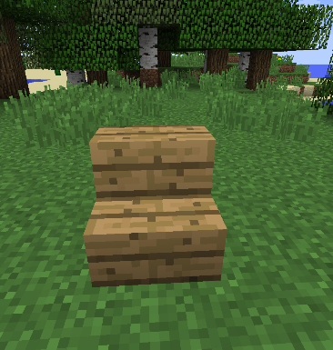

1. Right Click to sit on it.

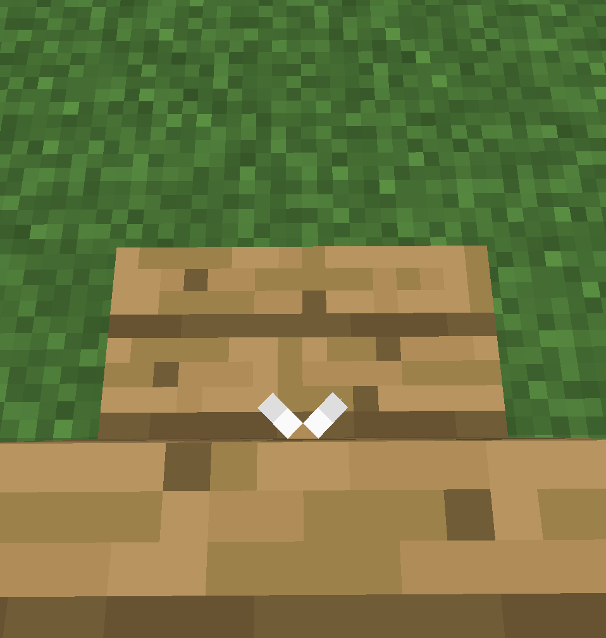 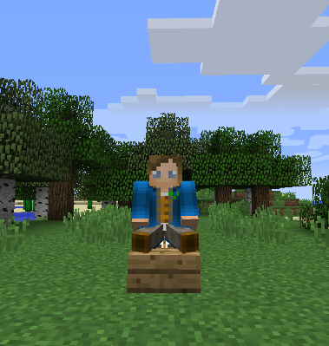

1. To get up from chair shift and right click.